|  |  |  |
| --- | --- | --- |
| **LAB 321Assignment** | **Type:** | **LongAssignment** |
| **Code:** | **3** |
| **LOC:** | **500** |
| **Slot(s):** | **3-4** |

**Title:** Comment approval

**Background**

The comment feature is very popular in almost interacted website. This is considered a good channel to gather the feedback information from the customer or potential customer.

But not all comments could be public due to some sensitive reasons. So the comment approval should be applied to help the site owner decide with comment could be public, which comment is not suitable.

**Program Specifications**

Within this assignment scope, you are requested to develop a comment feature for the content posted in the site. i.e. the user could leave their comment for each post .

Once receive the comment information from user, the owner review and click on "public" button on the comment record to public the comment.

After the comment being public, the audience can see the comment when browse the information of the product.

**Features:**

This website contains 2 main functions

* Function 1 : View post and add comment (PIC 1)

Develop a page that view a post (data to for the post could be add manually use SQL SERVER tools). At the end of this page, display all comments for the post and a form that allow user to post comment.

* Function 2 : List all comment for approval ( PIC 02)
  + List all the comment, and click on approve button, trash button…

You do not need to write interface for admin control panel, you can add data manually (use SQL SERVER Management studio).

Note: All data must be load from database, not hard code in page.

***Expectation of User interface:***

Pic 01 : Add new Product

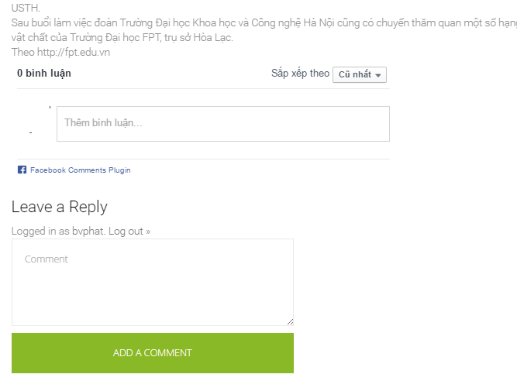

Pic 02 : list all commet with Approve button

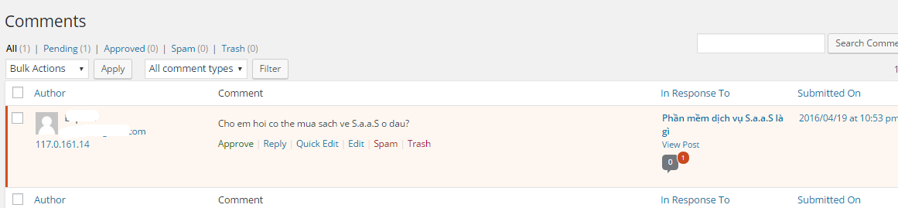

**Guidelines**

* Step 1 : Create web layout
* Step 2 : Create prototype
* Step 3 : Design database base on created prototype
* Step 4 : Code & Test